PASH Website editing

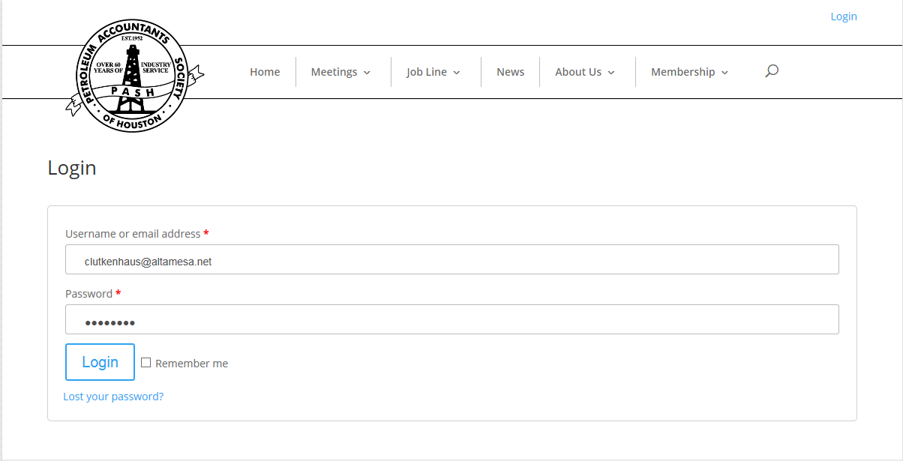

https://www.pashcopas.org/about-us/committees/
click on the committee to be edited
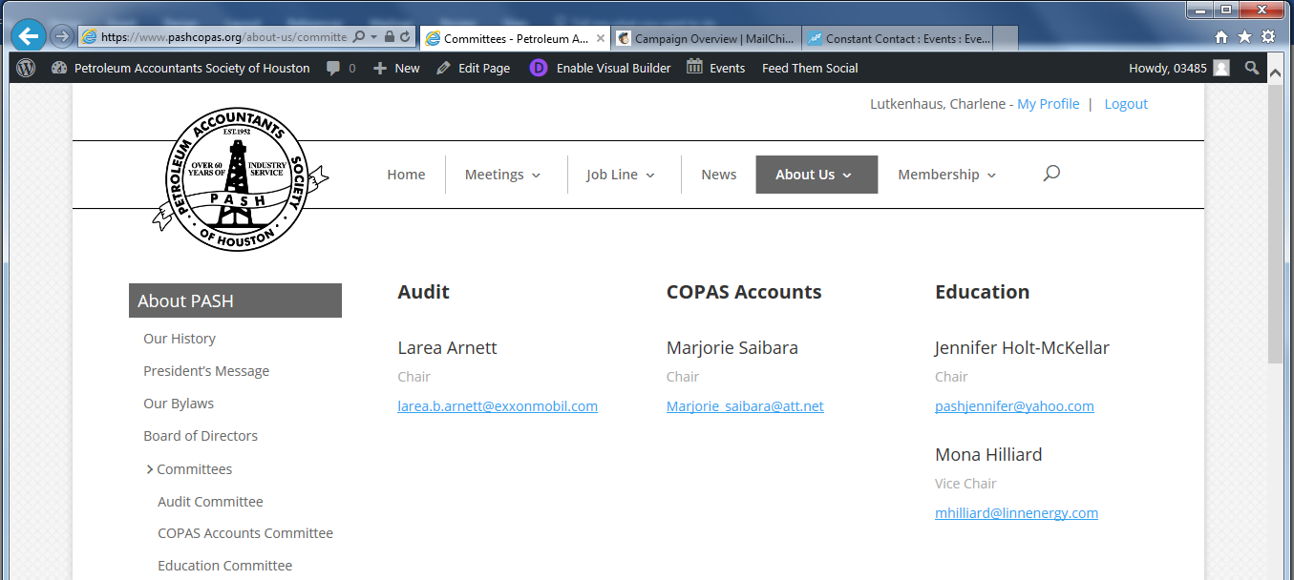

Once inside the committee webpage, click Edit Page
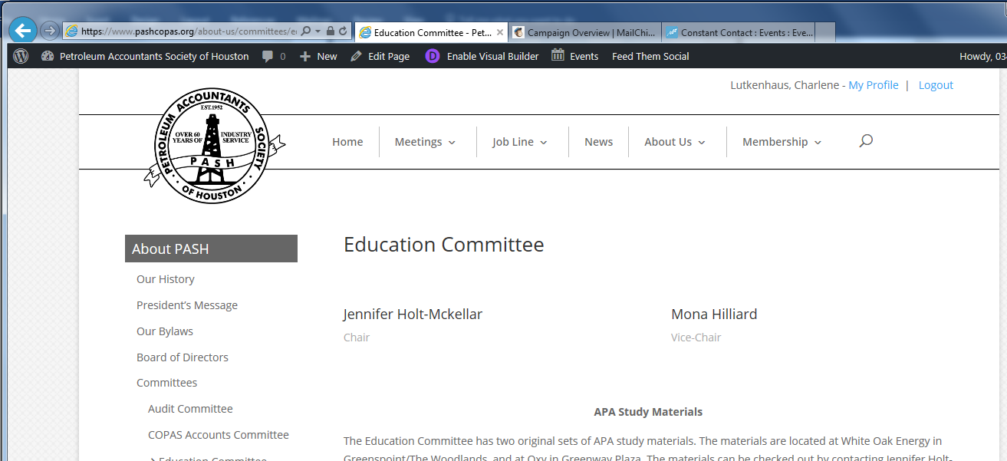

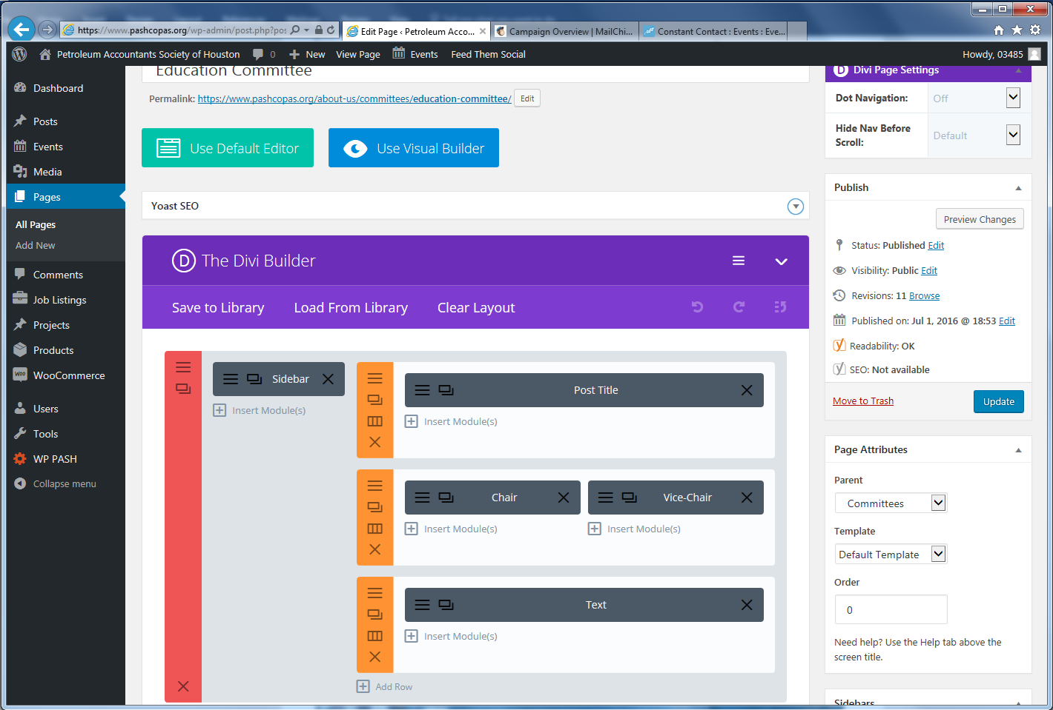

Content can be edited similarly to Microsoft Office products—copy, paste, bold, italics, etc.
If issues arise such as with spacing, switch to Text to edit manually, switch back to Visual to see results.
Always Save & Exit, then click Update for changes to be visible.
